SKH Lam Woo Memorial Secondary School
F.4 Economics (2021 - 2022)
Market intervention
Question bank design

 |  |  | Topic: price ceiling ↔ real-life example
QUESTION 1 |  | Past paper reference:2017 MCQ 18
Suppose the government imposed an effective rent control on living units. Which of the following would LEAST likely occur?

A. There would be a shortage of living units.
B. Black market would emerge.
C. Poor people would be able to rent a living unit more easily.
D. Landlords would have a lower incentive to renovate their living units for rent.
Suggested answer: C. There is a shortage in the living units market given the controlled price is below the market equlibrium, i.e. there are inadequate living units to satisfy the needs of tenants.
Option A is correct. The quantity demanded is larger than the quantity supplied at the controlled price.
Option B is correct. The landlord may impose ‘key money’ on the rental contract.
Option D is correct. After renovation, the rental rate charged may not be raised due to the effective rent control.

 |  |  | Topic: price ceiling ↔ demand-supply diagram
QUESTION 2 |  | Past paper reference: 2013 DSE Paper 1 (14)
Refer to the following demand-supply diagram:
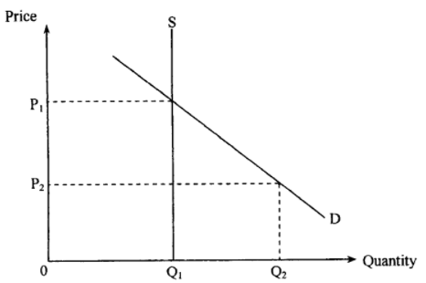
If the government raises the price ceiling from P₂ to P₁ , the total revenue received by the sellers

- will rise.
- will fall.
- will remain unchanged.
- may rise or fall, depending on the price elasticity of demand.
Suggested answer: A
Initial revenue (effective price ceiling): P₂ × Q₁
New revenue (ineffective price ceiling): P₁ × Q₁

 |  |  | Topic: price ceiling ↔ demand and supply schedule
QUESTION 3 |  | Past paper reference: HKCEE 1999 Paper 2 Question 6
Refer to the following supply and demand schedule for good X.
 | Unit price ($) | Quantity demanded (units) | Quantity supplied (units)
 | 7 | 8 | 20
 | 6 | 12 | 18
 | 5 | 16 | 16
 | 4 | 20 | 14
 | 3 | 24 | 12

The government sets its price ceiling at $4 per unit, what would happen if the government raised the price ceiling to $7 per unit?

- The shortage of X would disappear.
- The quantity transacted would decrease.
- Consumer expenditure on good X would decrease.
- The surplus of good X will decrease.
Suggested answer: A The main thing to note is that the ceiling turns from effective to ineffective. Option A is correct because a shortage is created with the effective price ceiling, and when it becomes ineffective the market returns to equilibrium.
Option B is incorrect because the quantity transacted should increase.
Option C is incorrect because both the price and the quantity transacted increase, and hence total consumer expenditure should rise.
Option D is incorrect because there was never a surplus present, both before the policy change and after.

Topic: price ceiling ↔ adjustment in existing market intervention
Past paper reference:HKCEE 1996/II/9
Suppose initially the price of property under Home Ownership Scheme (HOS) is fixed below the market equilibrium. Relaxing the price control will lead to

- an increase in the price of property under HOS.
- a decrease in demand.
- an increase in revenue only if the demand for this good is inelastic.
- an increase in revenue.

A. (1) and (2) only
B. (3) and (4) only
C. (1) and (4) only
D. (2) and (3) only
Suggested answer: C

Option (1) is correct. ∵ Below equilibrium=excess demand ∴relax price control→P↑
Option (2) is not correct. The demand curve remains unchanged.
Option (3) is not correct and option (4) is correct.. P↑ Q↑. The revenue will increase no matter if the elasticity of demand is larger or smaller than 1.

 |  |  | Topic: price ceiling ↔ elasticities
QUESTION 5 |  | Past paper reference: HKCEE 1992 MCQ 27
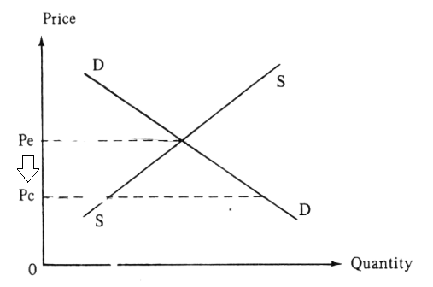

The above diagram shows the price and quantity of Good X. The price decreases from P_{e} to P_{c} after the price ceiling is imposed. As a result, the total expenditure on Good X will

A. increase
B. decrease
C. remain unchanged
D. either increase or decrease, depending on its price elasticity of demand

Suggested answer: B. The total expenditure must decrease as both price and quantity drop.
Option D is incorrect. The total expenditure must decrease under an elastic demand and an elastic demand.

 |  |  | Topic: price floor ↔ real-life example
QUESTION 6 |  | Past paper reference: 2013 DSE Paper 1 (15)
Suppose the government introduces an effective wage-price control which sets a minimum hourly wage the employers should pay the workers.Which of the following statements must be INCORRECT?

(1) There will be a shortage of workers.
(2) The employers will have less incentive to employ workers.
(3) The employers will spend less on maintenance of the working conditions.

- (1) only
- (1) and (3) only
- (2) and (3) only
- (1), (2) and (3)
Suggested answer: A

Statement (1) must be incorrect. An effective wage-price control implies that the minimum hourly wage is set above the equilibrium price, where the quantity supplied of workers must be greater than the quantity demanded of workers. There will be a surplus of workers instead of shortage.

Statement (2) is correct. The unit cost of employing a labour ↑

Statement (3) is correct. Given the controlled wage-level is higher than that of market equilibrium, employers may spend less on other remuneration packages (e.g. working conditions).

 |  |  | Topic: price floor ↔ demand-supply diagram
QUESTION 7 |  | Past paper reference:2013 DSE Past paper Q14
Refer to the following demand-supply diagram:

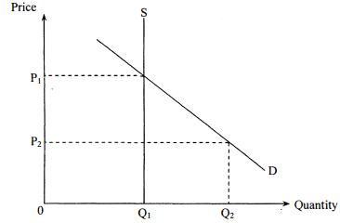

If the government lowers the price floor from P₁ to P₂,the total revenue received by the sellers

- will ries.
- will fall.
- will remain unchanged.
- may rise or fall, depending on the price elasticity of demand.

Suggested answer: C.
It is because the price floor is not effective in either P₁ or P₂.
The total revenues remains unchanged at P₁ ✕ Q₁.

 |  |  | Topic: price floor ↔ demand and supply schedule
QUESTION 8 |  | Past paper reference:
The following table supply and demand schedules of Good Y.

 | Price ($) | 40 | 45 | 50 | 55 | 60
 | Quantity demanded (units) | 200 | 180 | 160 | 140 | 120
 | Quantity supplied (units) | 80 | 100 | 120 | 140 | 160

If the government imposes a price floor of $120 on the Good Y, total expenditure of the good will

- decrease by $1700.
- decrease by $500.
- decrease by $300.
- remains unchanged.
Suggested answer: D. It is because the price floor is ineffective. The market price and quantity remains at $55 and 140 units at equilibrium respectively.

 |  |  | Topic: price floor ↔ adjustment in existing market intervention
QUESTION 9 |  | Past paper reference:HKCEE 2009 MCQ 11
The government is planning to increase the minimum wage across industries. A result of an effective minimum wage increase is that

A.the average wage earnings of employed low-income workers must increase.
B.the total wage earnings of employed low-income workers must increase.
C.the demand for low-income workers must decrease.
D.the supply of low-income workers must increase.

Suggested answer: A. P↑Qd↓ With the increase in wage rate and the decrease in the number of workers employed, the average wage earnings of employed low-income workers must increase.
Option B is incorrect. As the total wage earning of employed low-income workers is dependent on the elasticity of demand for workers, it may increase or decrease.
Option C is incorrect.The change of the minimum wage will not affect the demand for low-income workers.
Option D is incorrect.The change of the minimum wage will not affect the supply of low-income workers.

Teacher |  |  | Topic: price floor ↔ elasticities
QUESTION 10 |  | Past paper reference: HKCEE 2000 MCQ 6
Hong Kong’s recent economic recovery has caused a raise in people ’s income. In view of this, the government decided to raise the effective minimum wage level of Filipino maids. As a result of these TWO changes,

(1) the demand for Filipino maids should increase.
(2) the quantity supplied of Filipino maids should increase.
(3) the excess supply of Filipino maids should increase.
(4) the total expenditure on the employment of Filipino maids should raise.

A. (1) and (2) only
B. (2) and (3) only
C. (1), (2) and (3) only
D. (1), (3) and (4) only
Suggested answer: B

Statement (1) is not correct. The demand remains unchanged while the quantity demanded for Filipino maids will decrease.
Statement (2) is correct. According to the law of supply, the increase in wage rate will lead to an increase in quantity supplied.
Statement (3) is correct. The difference between quantity demanded and quantity supplied enlarges.
Statement (4) is incorrect. If the demand is elastic, the total expenditure will drop.

 |  |  | Topic: quota ↔ real-life example
QUESTION 11 |  | Past paper reference:
In 2007, the South African Government imposed a quota on the imports of clothing and textiles from China. As a result , ___________ in China will decrease

A. the price of clothing and textiles
B. the sales volume of clothing and textiles
C. the income of workers in the clothing and textiles manufacturing industry
D. the revenue from clothing and textiles sales

Suggested answer: C. The demand for workers will drop as it is derived from the demand of clothing and textiles.

Option A is not correct. The price will increase as the supply curve shifts leftwards.
Option B is not correct. The sales volume will drop as the supply curve shifts leftwards.
Option D is not correct. The revenue will drop if the demand is elastic.

 |  |  | Topic: quota ↔ demand-supply diagram
QUESTION 12 |  | Past paper reference: HKCEE 2006 MCQ 10
In country A, there is a quota restriction on imported good. When the import quota quantity is Q₁, the market price of the good is P₂. Now suppose Country A decreases the quota quantity from Q₁ to Q₃ as shown in the diagram below. As a
result, the new total sales revenue would be

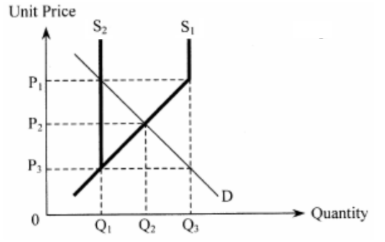

- P₁ ✕ Q₁
- P₂ ✕ Q₂
- P₁ ✕ Q₃
- P₃ ✕ Q₃

Suggested answer: A
Since the market equilibrium is set in Q₂, Q₃ is an ineffective quota while Q₁ is an effective quota.
Therefore the quantity transacted will decrease from Q₂ to Q₁ and the price will increase from P₂ to P₁.

 |  |  | Topic: quota ↔ demand and supply schedule
QUESTION 13 |  | Past paper reference: DSE 2019 Paper 1 Q16
Refer to the following supply and demand schedules of Good X.

Unit price ($) | 18 | 16 | 14 | 12 | 10 | 8 | 4
Quantity demanded (units) | 100 | 150 | 200 | 250 | 300 | 350 | 400
Quantity supplied (units) | 400 | 350 | 300 | 250 | 200 | 150 | 100

If the government decreases the quota for Good X from 350 units to 200 units, the market price will

- increase by $2.
- increase by $6.
- decrease by $2.
- decrease by $6.

Suggested answer: A
Market equilibrium : $12, 250 units
Quota : 350 units (ineffective) —> 200 units (effective)
When an effective quota is imposed, S↓, P↑Q↓
Market price : $12 —> $14 (increase by $2)

 |  |  | Topic: quota ↔ adjustment in existing market intervention
QUESTION 14 |  | Past paper reference: Textbook Unit 6 MCQ exercise
If the Hong Kong government raise the effective daily quota on fresh pork imported from the mainland, then

- the price of chilled pork in Hong Kong will increase.
- Hong Kong’s demand for fresh pork imported from the mainland will increase.
- the average quality of fresh pork imported from the mainland will decrease.
- the local supply of fresh pork in Hong Kong will decrease.
Suggested answer: C. The average quality will decrease the the relative price of high-quality fresh pork ↑ while the relative price of low-quality fresh pork ↓
Option A is not correct. P_{fresh pork} ↓, D_{chill pork} ↓ , P_{chill pork} ↓
Option B is not correct. The demand remains unchanged while the quantity demanded for fresh pork imported ↑
Option D is not correct. P_{fresh pork from mainland} ↓, D_{fresh pork in Hong Kong} ↓ , Qs_{fresh pork in Hong Kong} ↓, the supply remains unchanged.

 |  |  | Topic: quota ↔ elasticities
QUESTION 15 |  | Past paper reference: 2017 HKDSE MCQ24
Refer to the following figure of a good with a quota set at Q₁ by the government.
Which of the following will be the results of moving the quota from Q1 to Q2?

- The total expenditure of the good must increase.
- The market price will remain unchanged.
- The quantity transacted decreases.

- (1) and (2) only
- (1) and (3) only
- (2) and (3) only
- (3) only
Suggested answer: B
From the figure: The quota becomes effective when it is moved from Q₁ to Q₂. The demand is inelastic.
- is correct: The demand is inelastic, so the total expenditure of Good X increases when the quota becomes effective.
- is incorrect: The market price increases when the quota becomes effective.
- is correct: The quantity transacted decreases when the quota becomes effective.

 |  |  | Topic: unit tax ↔ real-life example
QUESTION 16 |  | Past paper reference:2015 DSE P1Q10
Which of the following will result in a rise in the total revenue of chicken farms?

A:The price of chicken feed falls
B:The government reduce the profit tax rate on chicken farms
C:The effective quota on the sale of chicken is increased
D:The government increase the tax for the producers of pork
Suggested answer: D
Pork and chicken are substitutes.
When tax increases,the production cost of pork will increase,which leads to the increase of demand of chicken.

 |  |  | Topic: unit tax ↔ demand-supply diagram
QUESTION 17 |  | Past paper reference:Past paper reference:HKCEE 2001 Paper 2 Q7
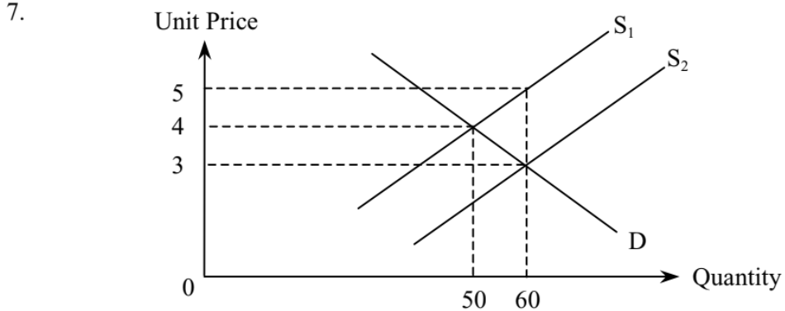

The above diagram shows the increase in supply of a good from S1to S2 as a result of the abolishment of a per unit tax for the good by the government. Suppliers’ new total revenue __________ their old total revenue (including the taxation) before the provision of the tax.

A. is smaller than
B. is equal to
C. is larger than
D. may be larger or smaller than

Suggested answer: A
Initial revenue: $4 ✕ 50 units = $200
New revenue: $3 ✕ 60 units = $180

 |  |  | Topic: unit tax ↔ demand and supply schedule
QUESTION 18 |  | Past paper reference:
Refer to the following demand and supply schedules of a Good Y.

Price($) | 20 | 23 | 26 | 29 | 32
Quantity demanded (Units) | 120 | 100 | 80 | 75 | 60
Quantity supplied (Units) | 80 | 80 | 80 | 80 | 80

If the government imposes a per-unit tax of $3 on Good Y, the new equilibrium price will be …

A.$20
B.$23
C.$26
D.$29
Suggested answer: C. As the supply is a fixed supply,the quantity supplied would not change after the imposition of a unit tax. Therefore,the equilibrium price would not change too.

 |  |  | Topic: unit tax ↔ adjustment in existing market intervention
QUESTION 19 |  | Past paper references: HKCEE 1999/II/8, DSE 2015/1/16
Refer to the following supply and demand schedule for good Y.

Unit Price ($) | 13 | 12 | 11 | 10 | 9 | 8
Quantity demanded (Units) | 40 | 60 | 70 | 120 | 140 | 160
Quantity supplied (Units) | 280 | 240 | 200 | 120 | 80 | 70

If the government imposed $3 per unit tax on Good Y, which of the following statements about Good Y is correct?

- Sellers’ revenue net of tax is $1200.
- The new market price is $10.
- The total tax revenue is $210.
- It is an inelastic demand.

Suggested answer: C. The total tax revenue = $3 ✕ 70 units = $210
Option A is not correct. Sellers’ revenue net of tax = ($11 − $3) ✕ 70 units = $560
Option B is not correct. The new market price is $11, given the new Qd and Qs are 70 units.
Option D is not correct. Elasticity of demand $=\frac{\frac{70 - 120 }{(70 + 120) ÷ 2}}{\frac{11 - 10 }{(11 + 10) ÷ 2}} X 100\%$≈ - 5.53%.
∴ It is an elastic demand.

 |  |  | Topic: unit tax ↔ elasticities
QUESTION 20 |  | Past paper reference: HKDSE 2019/I/Q14
Refer to the following market demand for imported soybeans in Country A.
Price ($) | 10 | 11 | 12 | 13 | 14
Quantity demanded (units) | 700 | 600 | 500 | 400 | 300
When the government of Country A imposes a per-unit tariff of $3 on imported soybeans, the equilibrium price of the imported soybeans increases from $11 to $12.

Which of the following statements are correct?

- The total sales revenue (net-of-tariff) of the imported soybeans is $4500.
- The supply of the imported soybeans is less elastic than the demand for them.
- Within the range of the original and the new equilibrium prices, the elasticity of demand of the imported soybeans is smaller than one.

- (1) and (2) only
- (1) and (3) only
- (2) and (3) only
- (1), (2) and (3)

Suggested answer: A
- total sales revenue (net-of-tariff) = ($12 − $3) ✕ 500 units = $4500
- buyers bear $1 tax, seller bears $2 tax
Supply is less elastic than demand
- Ed = $\frac{\frac{500 - 600 }{(500 + 600) ÷ 2}}{\frac{12 - 11 }{(12+ 11) ÷ 2}}X100\%$ ≈ - 2.09%.
The elasticity is larger than 1 in absolute value.

 |  |  | Topic: unit subsidy ↔ real-life example
QUESTION 21 |  | Past paper reference:
If a government abandons the policy of giving subsidies to farm products, then the price of farm products will __________ and the quantity of farm products transacted will __________.

- increase, increase
- decrease, decrease
- increase, decrease
- decrease, increase
Suggested answer: C. The supply curve shifts upwards and leftwards. The equilibrium price will increase and the quantity transacted will decrease, given the downward-sloping demand curve.

 |  |  | Topic: unit subsidy ↔ demand-supply diagram
QUESTION 22 |  | Past paper reference:HKCEE 2000 Paper 2 Q11
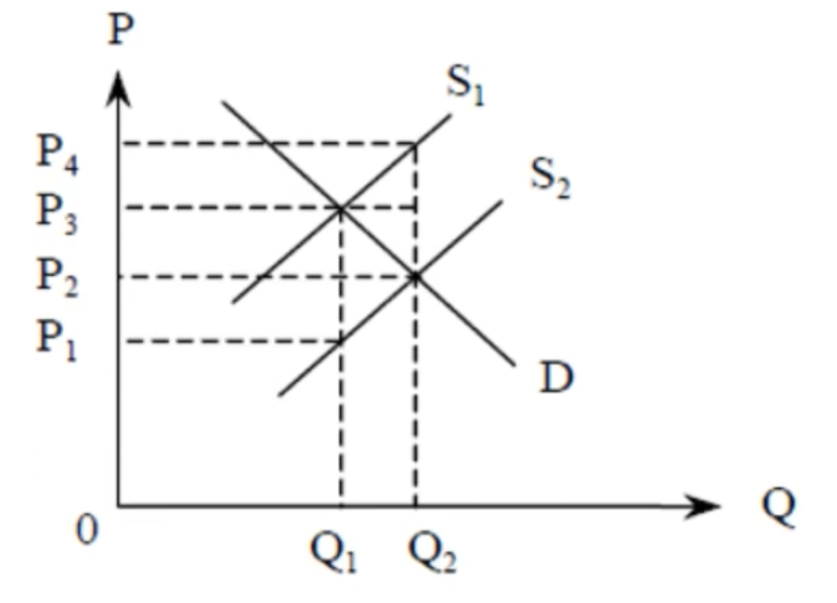
Suppose the government imposes a unit subsidy on good Y causing a shift of its supply curve from S₁ to S₂. The amount of subsidy benefit enjoyed by the consumers of good Y is

- (P₂ − P₁) ✕ Q₁
- (P₃ − P₁) ✕ Q₁
- (P₃ − P₂) ✕ Q₂
- (P₄ − P₃) ✕ Q₂
Suggested answer: C. The price changes reflected the unit subsidy enjoyed by the consumers = $ (P₃ − P₂).
The new quantity transacted is Q₂, given the intersection point of initial demand curve and new supply curve S₂.
Option D is not correct. It is the amount of subsidy benefit enjoyed by the sellers.

 |  |  | Topic: unit subsidy ↔ demand and supply schedule
QUESTION 23 |  | Past paper reference: 2013 DSE Paper 1 (13)
The following table shows the demand and supply schedule of good X.

Price ($) | 2 | 3 | 4 | 5 | 6 | 7 | 8
Quantity demanded (units) | 90 | 80 | 70 | 60 | 50 | 40 | 30
Quantity supplied (units) | 30 | 40 | 50 | 60 | 70 | 80 | 90

Suppose the government imposes a $2 per-unit subsidy on each unit of good X sold. The total sales revenue excluding the subsidy is

- $180
- $200
- $280
- $300
Suggested answer: C. $4 ✕ 70 units = $280.

Price ($) | 2 | 3 | 4 | 5 | 6 | 7 | 8
Quantity demanded (units) | 90 | 80 | 70 | 60 | 50 | 40 | 30
INITIAL quantity supplied (units) | 30 | 40 | 50 | 60 | 70 | 80 | 90
NEW quantity supplied (units) | 50 | 60 | 70 | 80 | 90 | - | -

 |  |  | Topic: unit subsidy ↔ adjustment in existing market intervention
QUESTION 24 |  | Past paper reference:2015 DSE Paper 1 Q10
Which of the following will result in a fall in total revenue of chicken farms?

A.The price of chicken feed rises.
B.The government raises the profit tax rate on chicken firms
C.The effective quota on the sale of chicken has decreased
D.The government raises the unit subsidy for the production of pork

Suggested answer: D, when the government raises the unit subsidy for the production of pork, the cost of production of each unit of pork decreases,and the supply of pork increases .The supply curve will shift downwards and rightwards..As pork and chicken are substitutes and the price of pork decreases, the demand of chicken falls, leading to a decrease in the price and quantity transacted of chicken, thus the total revenue of chicken farm falls.

Option A is not correct. The drop in supply may lead to a rise in total revenue, given an inelastic demand.
Option B is not correct. The total revenue remains unchanged while the total profits of the chicken farms drops, given the fixed and variable costs.
Option C is not correct. The drop in supply may lead to a rise in total revenue, given an inelastic demand.

 |  |  | Topic: unit subsidy ↔ elasticities
QUESTION 25 |  | Past paper reference: 2015 DSE Paper 1 Q12
The government provides a per-unit subsidy of $10 on producing masks. The market price drops by $4 as a result. Which of the following statements about the mask market is/are correct?

- The supply of masks is less elastic than their demand.
- Consumers enjoy less subsidy benefits than producers.
- The demand for masks increases.

- (2) only
- (1) and (2) only
- (1) and (3) only
- (1), (2) and (3) only
Suggested answer: B
- is correct. ∵ Consumers’ share of subsidy < Producers’ share of subsidy ∴ The supply is less elastic than demand.
- is correct. Consumers’ share of subsidy : Producers’ share of subsidy = 4:6
- is incorrect. The demand curve remains unchanged.

